1.Visualization of top 10 tallest buildings in the world.

DESCRIPTION: This is the dataset of the tallest buildings across the world that is downloaded f from https://www.kaggle.com/datasets. Out the 78 records that are available in the dataset, we are going to visualize the top 10 tallest buildings.

    - Getting the top 10 tallest buildings.
From the given dataset our aim to get the top 10 tallest buildings. For this we start with importing the required libraries and then import the required dataset.
Importing libraries:
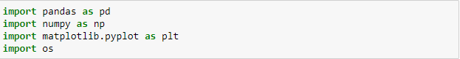
Importing dataset and reading first 10 records:
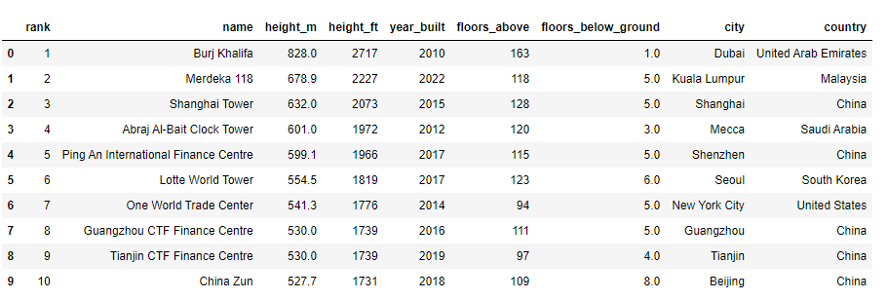
The next step is checking if there are empty values, missing values, or noisy data. If there is any noisy data, then we clean the dataset. Since we need only the top 10 values, we are going to check if there is noisy data in the first 10 records only.
Checking for noisy data:
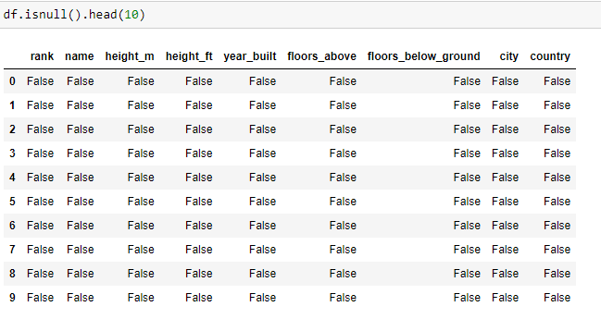
As we can see that there are no empty values in the dataset for the top 10 records. We can move on to the next step, that is plotting.
We start by declaring the figure size of the graph:
For this bar graph visualization, I wanted to display the height on the bars. So I created a function for this.
The function is as follows:
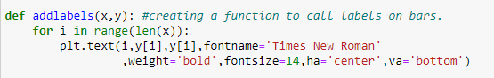
The step is to assign the values of x and y since we used the x and y in our function. After doing this, we can plot the graph using the plot function.
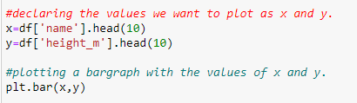
It is important to set the title and label names to the graph. While giving the label names, we call the function we have created earlier so that the height (in meters) is displayed on top of the bars.
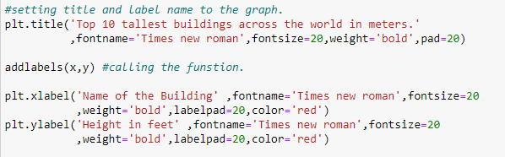
As the graph is plotted, I noticed that the tick values on the x axis are obscure and unclear. So, I decided to give a clean look to both x and y axis ticks.
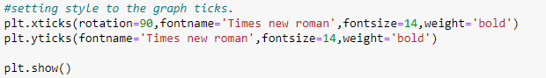
Here is the final plot of the top 10 tallest buildings in the world by their height in meters.
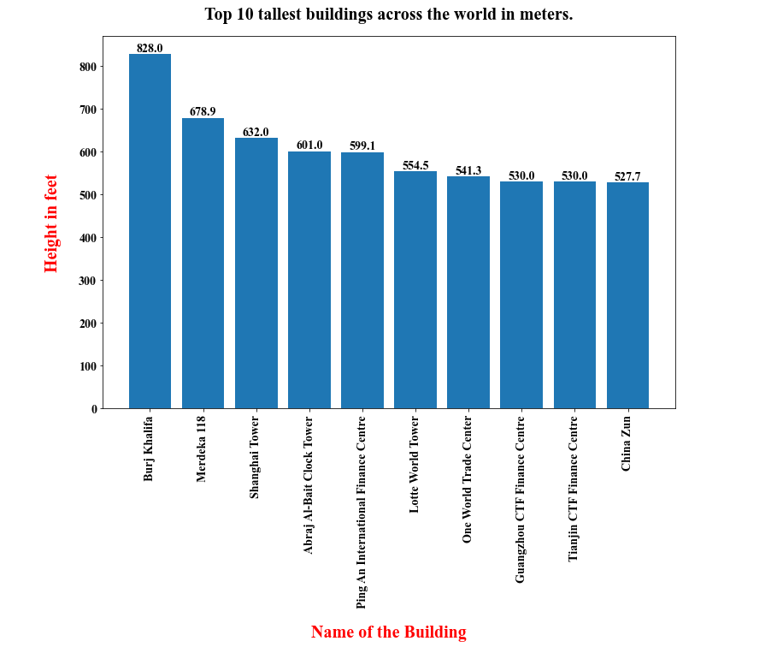
From the above graph, we can clearly read the top 10 tallest buildings according to their height in meters. We can clearly see the height of each building on the top of the bar plot.
CONCLUSIONS:
The data was cleaned and plotted using various data visualization techniques. The output of the process was a bar graph representing the top 10 tallest buildings around the world.

